# **AIF Cross Location Training**

# **28th to 30th July 2020**

# **Hands-on Reference Document for RFC**

# Abhishek Juyal

# Scenario Description:

We will create a RFC in ECC system to create the Purchase Order

The RFC will receive the below data:

* Material Number
* Vendor Number

The RFC will return the below data to the caller:

* PO Number

The entire interface development with AIF can be divided into 4 parts:

1. Prerequisite for AIF Configuration
2. AIF Configuration
3. ABAP Code to fetch and process data
4. AIF Error monitoring configuration

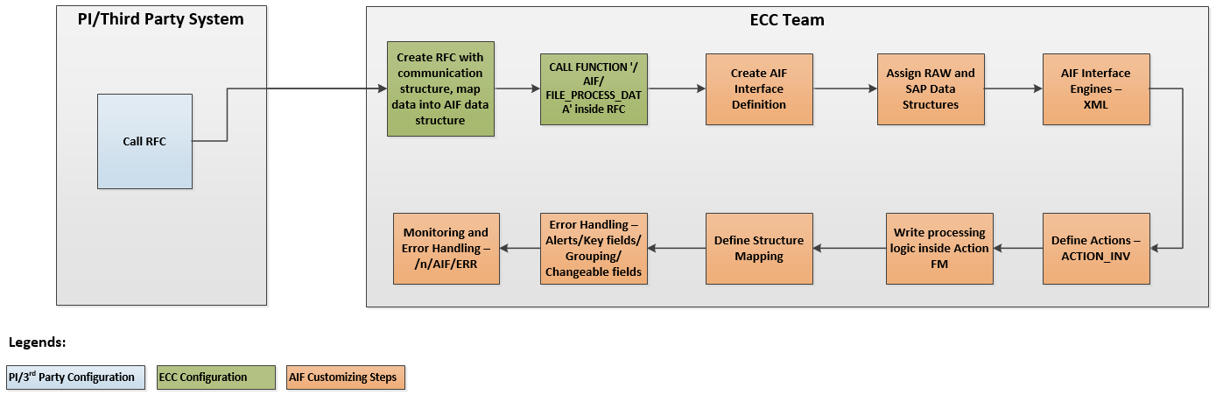

# Prerequisite for AIF Configuration

* 1. Create Data Dictionary structure for data mapping
     1. Go to SE11 and create a nested structure or use the transaction code ‘/AIF/RFC_FUNC_GEN’.

SAP Example

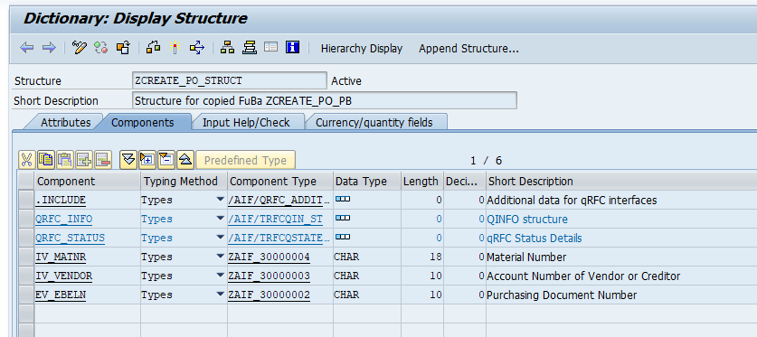

* 1. Create Action Function Module. Copy the standard FM /AIF/FILE_TEMPL_PROCESS and create a new custom function module. The role of action FM will be explained later in this document.

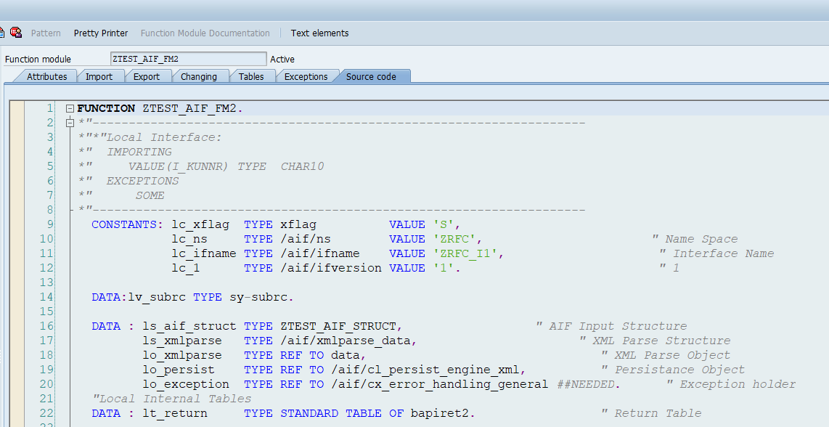

# AIF Configuration

All AIF configurations are carried out in transaction /AIF/CUST.

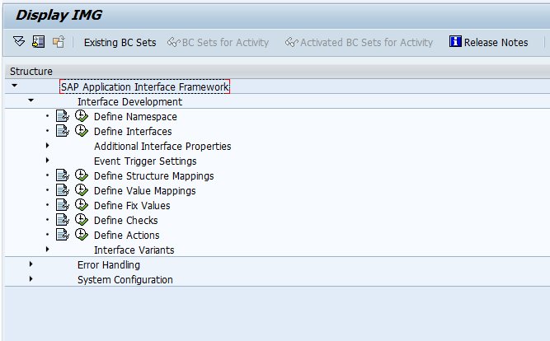

This section focuses on the Interface Development part of the AIF Configuration.

1. **Namespace –** Namespace is like a folder to logically group the interfaces. E.g. a single namespace for all interfaces of Country GB
   1. If Namespace is not available for your interface, create a new one:

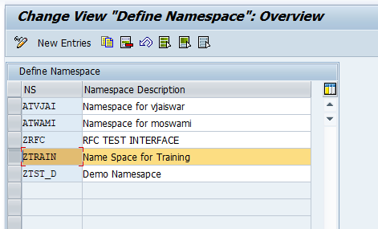

1. **Interface –** this represents the interface intended to be implemented with AIF. All mappings, value assignments etc. will be carried out against the interface. Follow the below steps to create interface
   1. Execute **Define Interface**

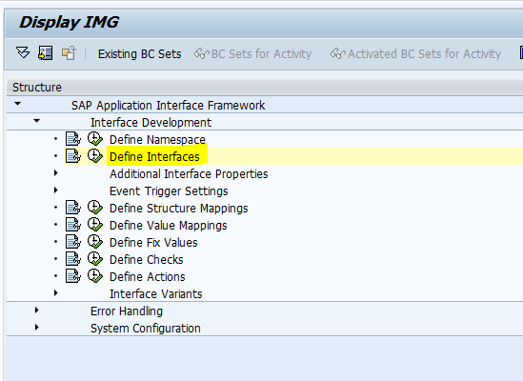

* 1. Provide the **Namespace**

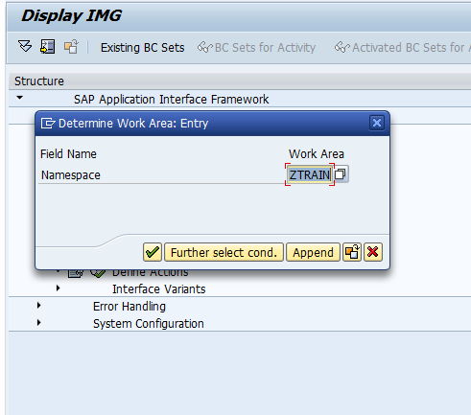

* 1. Create **New Entry**
  2. Fill the below highlighted details. SAP and Raw data structure fields will have the same structure name created in **step 2.1**

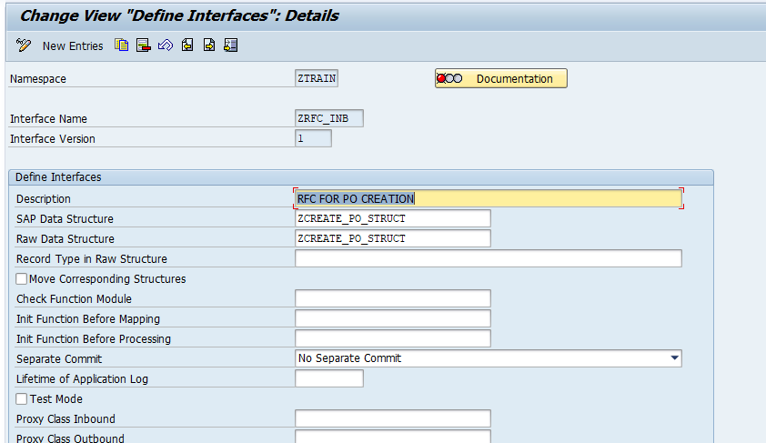

1. **Interface Engine –** specify interface engines for different AIF processing
   1. Go to /AIF/CUST and execute **Interface Development 🡪 Additional Interface Properties 🡪 Interface Engine**

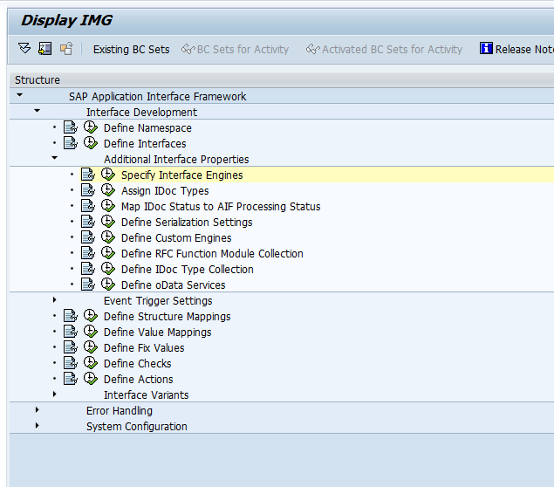

* 1. Enter the **Namespace** and continue

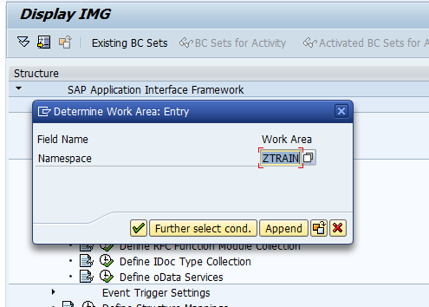

* 1. Fill Interface Name, Version and below Engine details

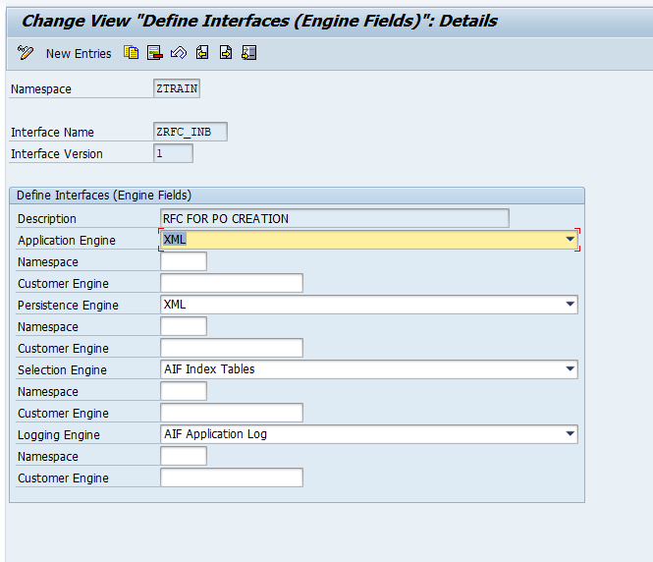

1. **Create Action –** Create Action name and assign the Action FM to the Action
   1. Go to /AIF/CUST and execute the node **Interface Development 🡪 Define Action**

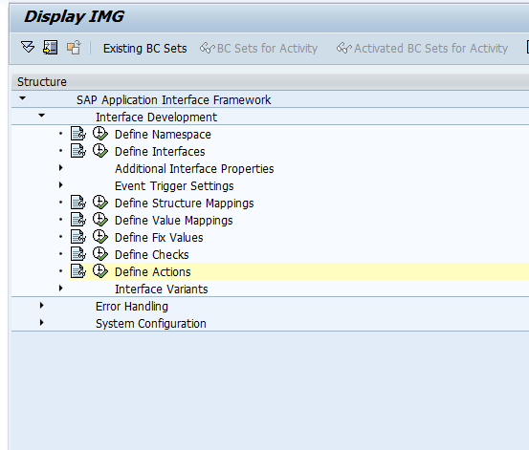

* 1. Enter the **Namespace** and continue



* 1. Create a new Action and provide the below highlighted details

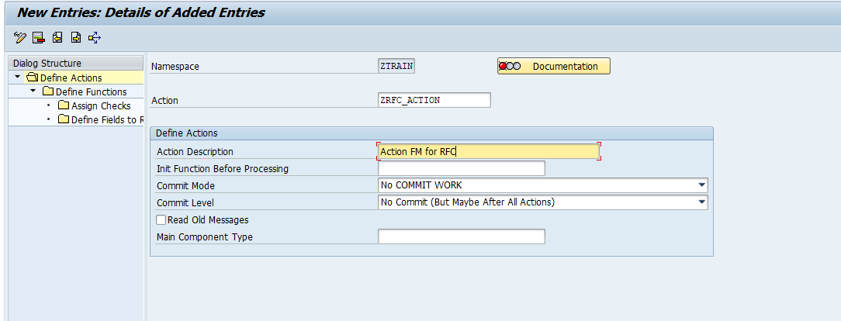

* 1. Assign Action FM to Action - Double click on **Define Function** on left hand side panel

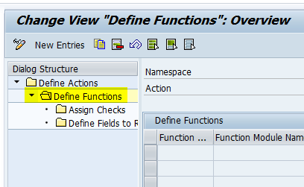

* 1. Enter the Action FM name create in step **2.2**

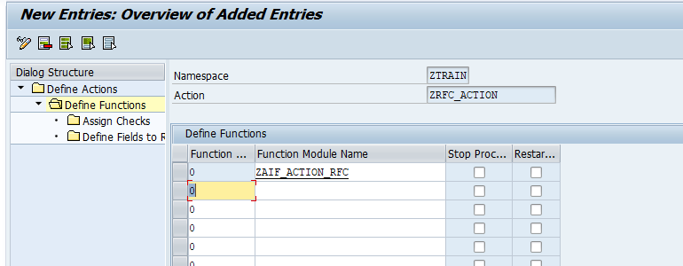

1. **Assign Action to Interface**
   1. Execute **Interface Development 🡪 Define Structure Mapping**
   2. Enter **Namespace, Interface Name and Version** 🡪 Continue

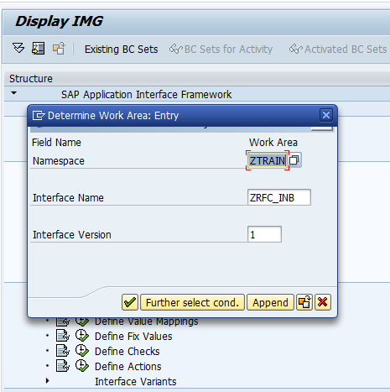

* 1. Double click on **Assign Action**

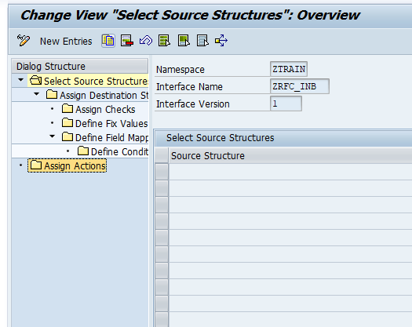

* 1. Create New Entry and assign the action name created in step 4

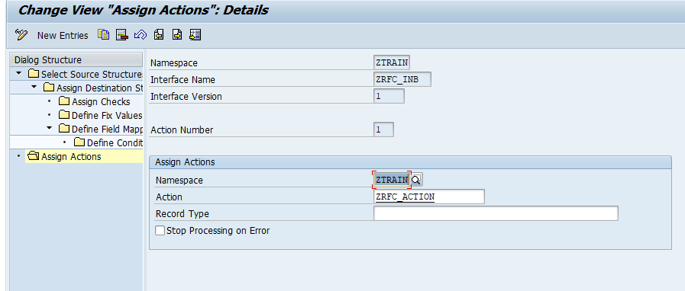

* 1. Save the entry.

# ABAP Code

* 1. Create a RFC as per the business requirement defined in section 1.
     1. Go to SE37 and create a Function Group
     2. Go to SE37 and Create RFC. Use the function group created in above step

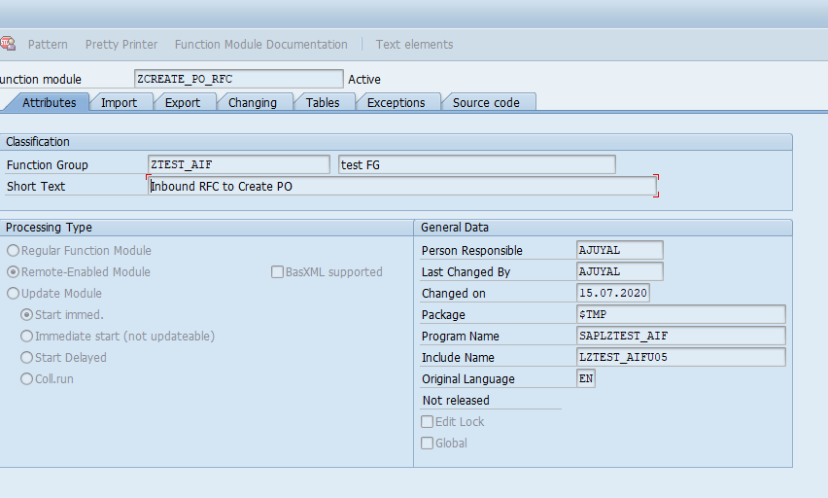

* + 1. Create Import and Export parameters as per the requirement

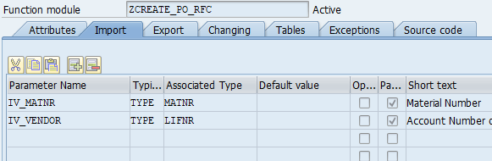

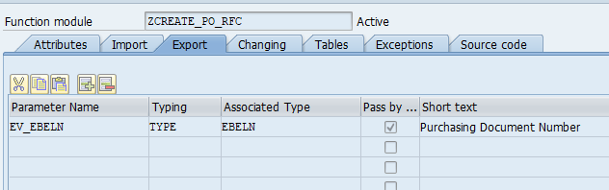

* + 1. Write the below code in the RFC



Change the constants value as per your Namespace, Interface name and version

# AIF Error Monitoring Configurations

* 1. **Create Module Pool Program for Filtering** 
     1. Create a module pool program SAPMZ_MAT_DETAILS in SE80.
     2. Create a sunscreen and add the parameters required for Filtering

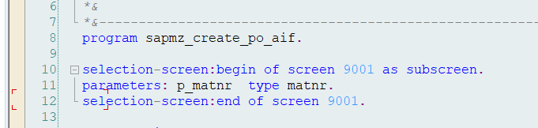

* + 1. Pass these parameters values to AIF by calling the method /AIF/CL_GLOBAL_TOOLS=>GET_VALUE_FROM_MEM ( ).

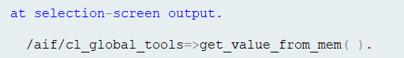

* 1. Create **Standard Index Table** and **Multi-index table**
     1. Standard Index Table - Copy standard table /AIF/STD_IDX_TBL and create a custom standard index table. This table will be used to group interface messages

Add an additional field MSG_GROUP (or any name) at the end of the table fields. The length of this fields depends on the combine length of the fields to be used in grouping.

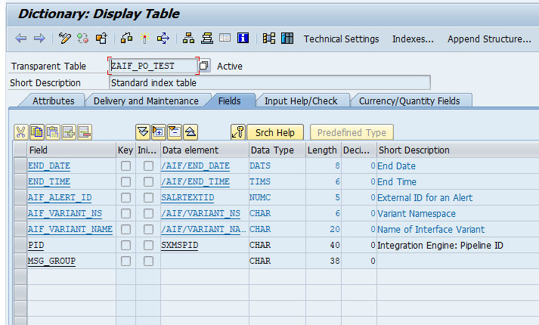

* + 1. Multi-index table – Copy standard table /AIF/STD_IDX_TBL and create a custom table. Make the below changes
       1. Add a counter field

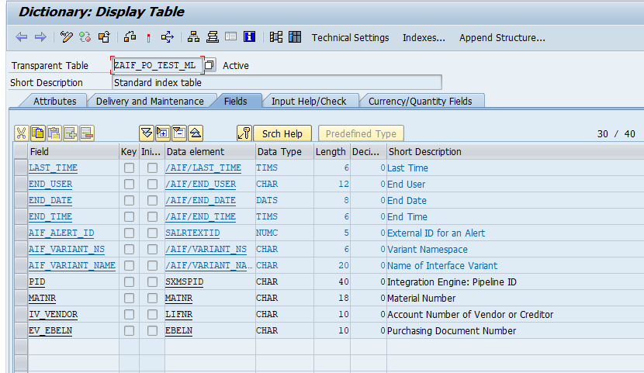

* + - 1. Add the fields at the end which are to be used in filtering purpose. This list of field is same as the parameters added in module pool program.
  1. **Configure Error Monitoring in /AIF/CUST**
     1. Go to /AIF/CUST and Execute the node **Error Handling 🡪 Define Namespace-specific Features**
     2. Enter **Namespace**

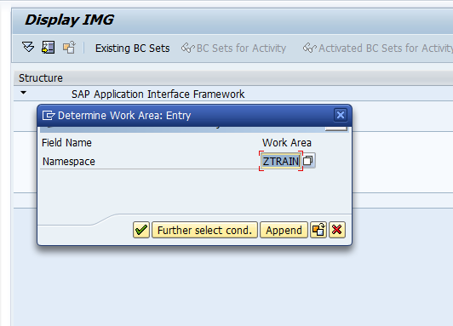

* + 1. Create a new entry under Dialog **Define Interface-specific Features**

* + 1. Enter the **Standard Index table**, **Module pool program** and **screen number** as shown in below screenshot

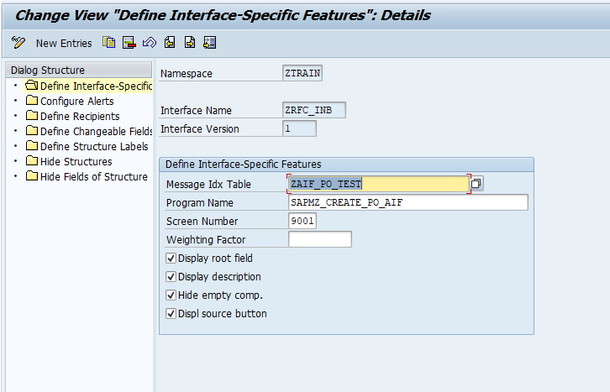

* + 1. Go to /AIF/CUST and Execute the node **Error Handling 🡪 Define Interface-specific Features**
    2. Enter **Namespace, Interface Name** and **Version** and continue

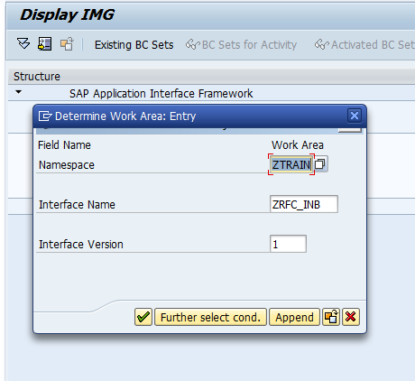

* + 1. Select **Define Key Fields for Multi. Search** and create new entry

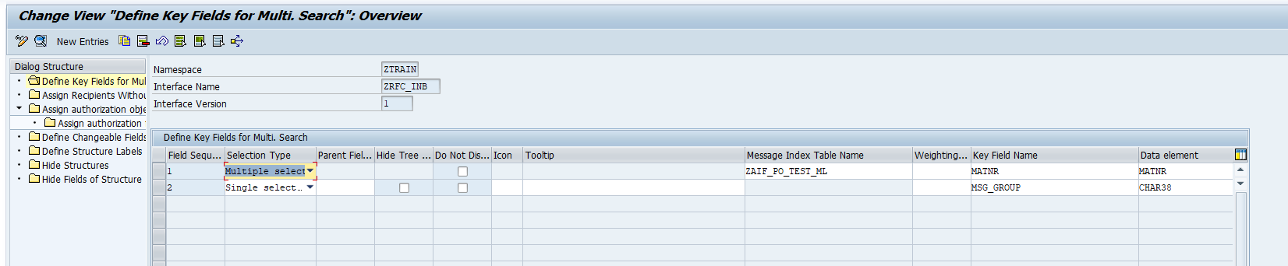

* + 1. Fill the below details. Multi index table is created in step 5.2.2

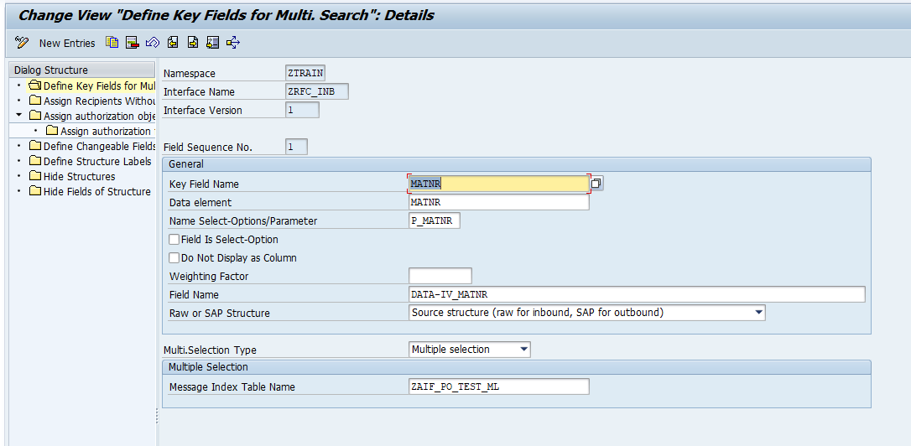

Similarly create more search fields for other key parameters

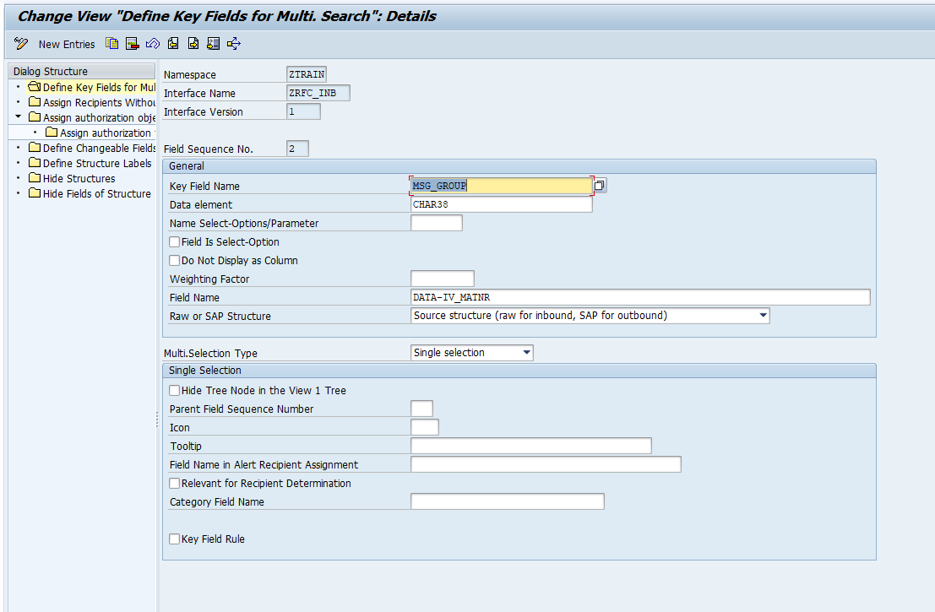

Save the entries.

Interface can be monitored in transaction **/AIF/ERR**

Enter the interface details

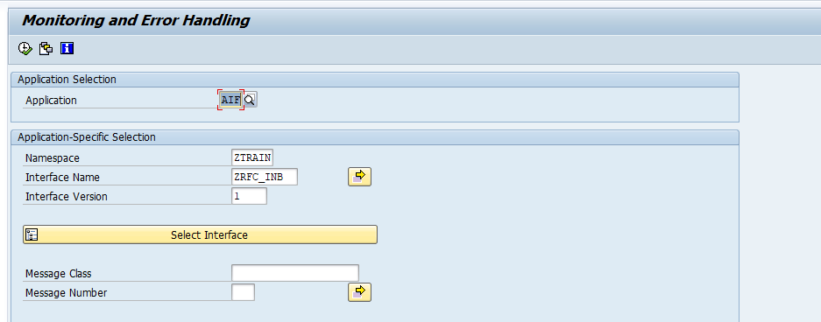

Enter date range and interface status

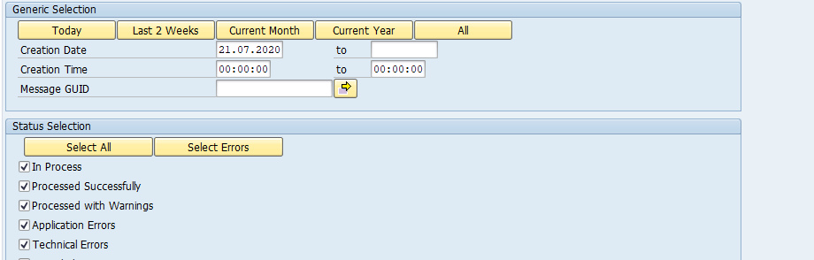

If Error monitoring is implemented with filtering capabilities, below additional selection screen can be available for further selection restrictions:

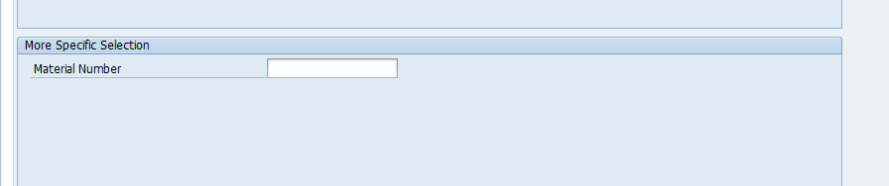

Error Handling Screen Output

